Q1. I : Enter Temperature celcius

P : Convert celcius to fahrenheit

O : Display Fahrenheit

Start

Read celcius

Fahrenheit, fahrenheit = 32+(9\*celcius/5)

Print fahreneit

End

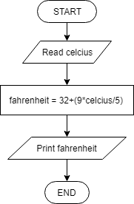

Q2. I : Read steps

P : Calculate miles

O : Display miles

Start

Read steps

miles = steps\*2.5/5280

Print miles

End

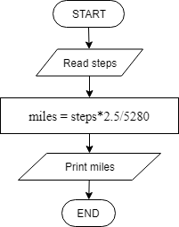

Q3. I : Read num1 and num2

P : - Calculate sum and difference

- determine whether sum is bigger than difference or difference is bigger than sum

O : print sum or difference based on whether sum or difference is bigger

Start

Read num1, num2

Calculate sum, differ

If sum>differ

Print sum

Else

Print differ

End if

Endy

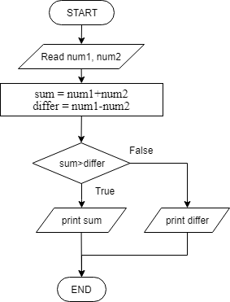

Q4. I : Read participant, weight, height

P : Repeat and calculate BMI based on participant

O ; Display BMI

Start

Read Participant

Set c=0

While c<participant

Read height, weight

BMI = wight/(height\*height)

If BMI <18.5

Print “Underweight”

Else if BMI<= 25

Print “Normal”

Else

Print “Overweight”

End if

Endwhile

End

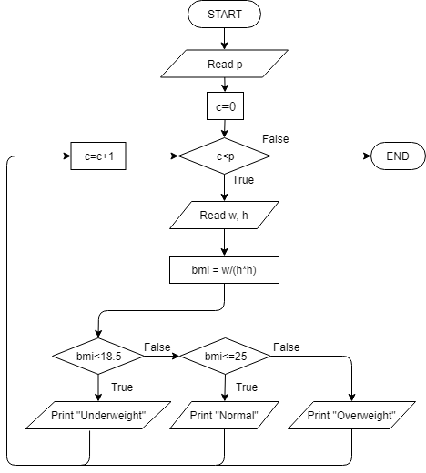

Q5. I : Read number

P : - Count positive and negative number

- Calculate total and average

- Determine smallest and biggest number

O : Print the amount of positive and negative numbers, total, average, the smallest number aaa and the biggest number

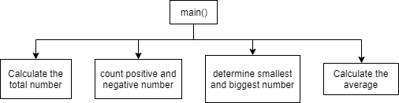

Start

Read num

Set sum = 0, tnum = 0, small = num, big = num, posNum = 0, negNum = 0

While num != 0

sum = sum+num

if num>0

posNum=posNum+1

else

negNum=negNum+1

end if

if num>big

big = num

end if

if num<small

small = num

end if

tnum = tnum+1

Read num

Endwhile

avg = sum/tnum

Print sum, avg, posNum, negNum, big, small

End

